|  |  |
| --- | --- |
| EX.NO: 5  DATE: | **E-LEARNING** |

**AIM:**

To develop the Online Website for E-LEARNING using HTML, CSS…

**PROBLEM STATEMENT:**

There is a growing demand for flexible and accessible education that caters to the needs of learners of all ages and backgrounds. Traditional brick-and-mortar educational institutions often face challenges in meeting these demands due to limited resources, infrastructure, and geographical constraints. As a result, there is a need for an e-learning website that provides an innovative and inclusive platform for learners to access high-quality educational resources from anywhere in the world.

**OBJECTIVES:**

One of the primary objectives of an e-learning is to simplify and learn the new ideas and courses for students.

|  |  |
| --- | --- |
| **1** | **INTRODUCTION** |
| 1.1 | Purpose |
| 1.2 | Product scope |
| **2** | **OVERALL DESCRIPTION** |
| 2.1 | Product perspective |
| 2.2 | Product functions |
| **3** | **REQUIREMENT SPECIFICATION** |
| 3.1 | User Interface |
| 3.2 | Software and Hardware |
| 4 | System features |

**SRS (SOFTWARE REQUIREMENT SPECIFICATION)**

**1. INTRODUCTION:**

**1.1 Purpose**

A e-learning website is a collection of courses and experienced mentors. The purpose of an e-learning website is to provide learners with a comprehensive and inclusive learning environment that meets their needs and enables them to achieve their educational and career goals.

**1.2 Product Scope**

The product scope of an e-learning website includes all the features, functionalities, and services that the website provides to learners, instructors, and administrators which includes course catalogue, course materials, etc.

**1.3 Definitions, Acronyms, and Abbreviations**

* E-learning: The process of delivering educational content and resources to learners through digital means, such as computers, tablets, or smartphones.
* LMS: Learning Management System
* MOOC: Massive Open Online Course
* VLE: Virtual Learning Environment

**2. Overall Description**

**2.1 Product Perspective**

The product perspective of an e-learning website involves understanding the relationship between the website and its users, as well as its place within the broader educational landscape.

**2.2 Product Functions**

This software includes details of courses such as:

**2.2.1 Course creation and management**

The website should allow instructors or administrators to create and manage courses, including adding course materials, assessments, and assignments.

**2.2.2 Course delivery**

The website should enable learners to access course materials, complete assignments and assessments, and communicate with instructors and peers.

**2.2.3 Progress tracking and reporting**

The website should track learners' progress through courses and provide reports to instructors or administrators on learner performance.

**2.2.4 Certification and credentialing**

The website should enable learners to earn certifications or credentials upon completing a course or program.

**2.3 General Constraints**

E-learning websites require resources to develop and maintain, including funding, staffing, and infrastructure. It must provide high-quality content that is relevant, engaging, and effective for learning. It may face barriers to access, particularly for learners who lack reliable internet access or who have limited digital literacy.

**3. External Interface Requirements**

**3.1 User Interfaces**

* Course dashboard: The website should provide a dashboard or landing page for each course that displays important course information, progress tracking, and links to course materials and assignments.
* Assessments and assignments: The website should enable instructors to create assessments and assignments with different question types, such as multiple-choice, fill-in-the-blank, and essay questions, and provide feedback and grading features for instructors.
* Multimedia content: The website should enable instructors to add multimedia content such as videos, images, and interactive simulations to course materials, and provide easy-to-use playback and display controls for learners.

**3.2 Hardware Interfaces**

Processor : Intel core i3

Process speed : 1.7 GHz

Memory : 4GB

Hard drive : 443

**3.3 Software Interfaces**

Operating system : Windows 7,8,10 or 11

Front End : HTML, BOOTSTRAP, JS

Back End : MYSQL

**4. System Features**

This system contains 5 modules in it. They are given below:

1. Categories

2. Courses

3. MyLearning

4. Community

5. Certificate generation

**UML DIAGRAM**

**1.USECASE DIAGRAM:**

A use-case diagram is graphical depiction of a user’s possible interactions with the system. It describes the high level functions and scope of a system. The use-case and actors in use-case describe what the system does and how the actors use it, but not how the system operate internally.

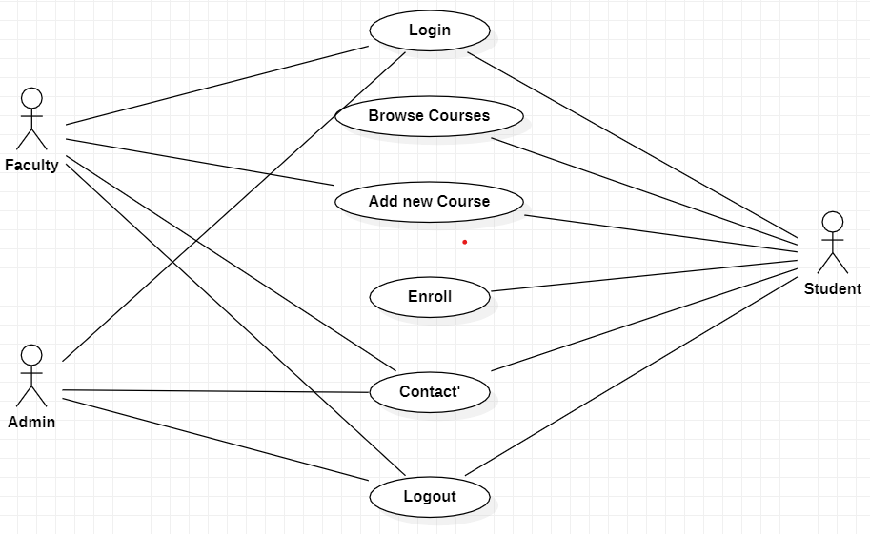

**2.CLASS DIAGRAM:**

Class diagram is illustration of the relationship and source code dependencies among classes in the Unified Modelling Language. Class diagrams are the blueprints of your system or subsystem.

**3.STATE CHART DIAGRAM:**

State chart diagram is used to describe behavior of the system and composed of finite no of states. It enables nice separation of concerns between behavior or logic and presentation

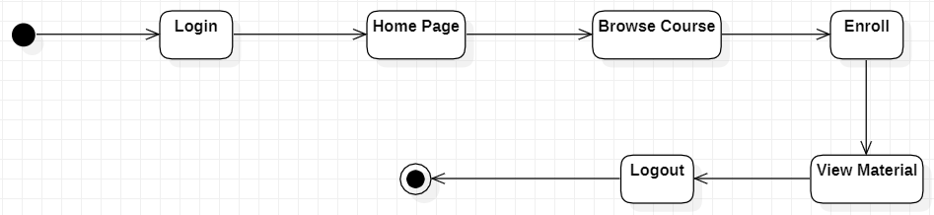

**4.COMPONENT DIAGRAM:**

A component diagram, also known as a UML component diagram, describes the organization and wiring of the physical components in a system.

**5.DEPLOYMENT DIAGRAM:**

In UML, deployment diagrams model the physical architecture of a system. Deployment diagrams show the relationships between the software and hardware components in the system and the physical distribution of the processing.

**SCREENSHOTS:**

**HOME PAGE:**

The homepage should include a navigation bar, a header with a title, and a section that provides brief information about the website. It should also include links to the courses page, login process page, Dashboard page, and contact us page.

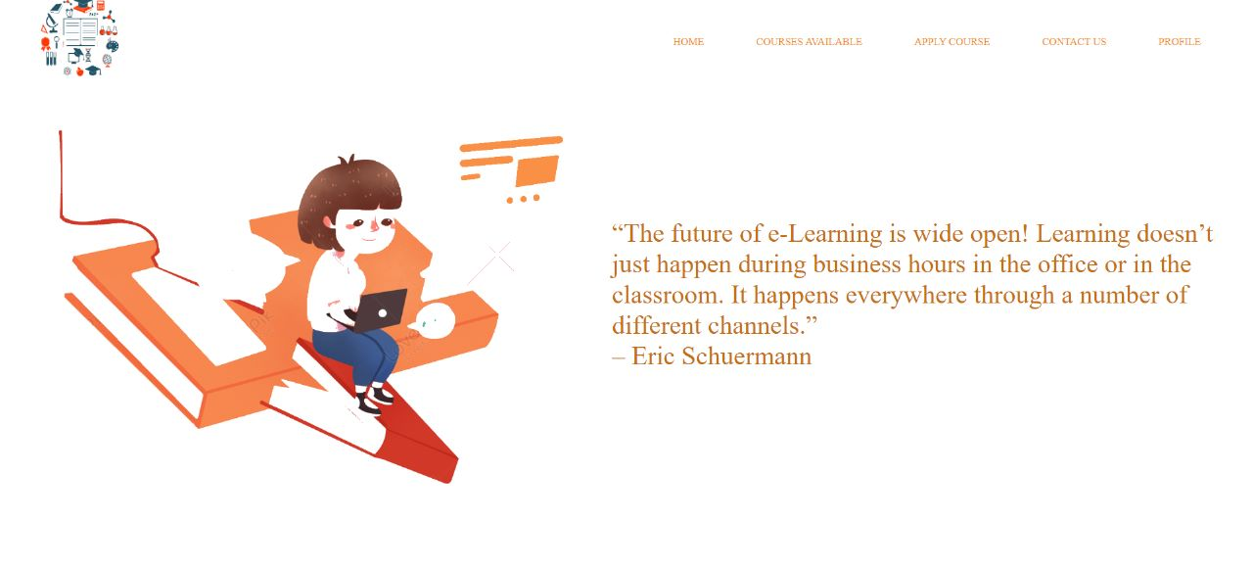

**APPLICATION PAGE:**

The Application page consist an Application form where the student can enter his or her details and what course he or she want to pursue and apply for the course in this page.

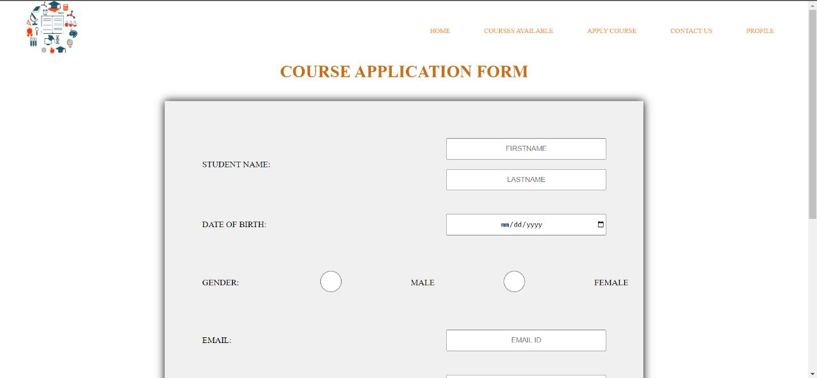

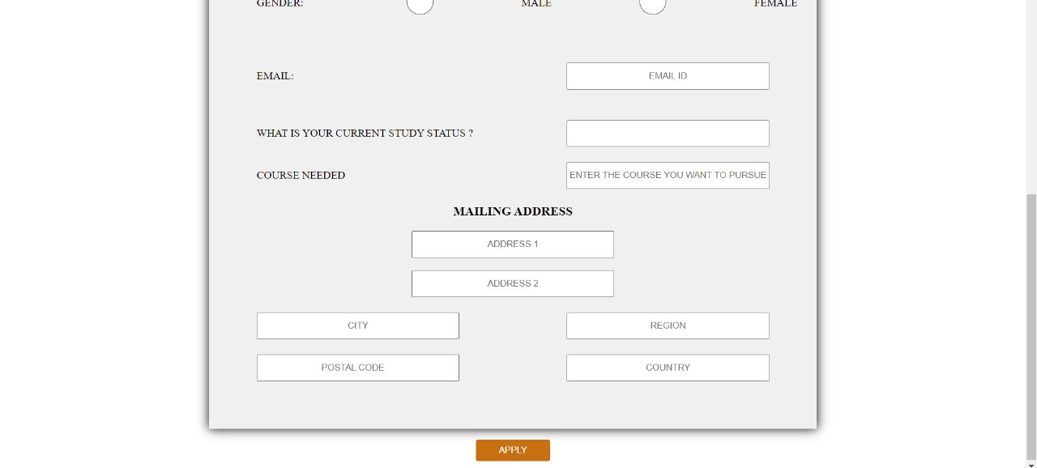

**COURSES PAGE:**

This page should include a list of courses and benefits about e-learning.

It also consists of different types of courses which is available currently in the

blog website.

**PROFILE PAGE:**

This page should includes about the badges won ,certificates won, and prizes won. It also specifies the workdone by the customers and their achievements hence it notified as my achievements page.

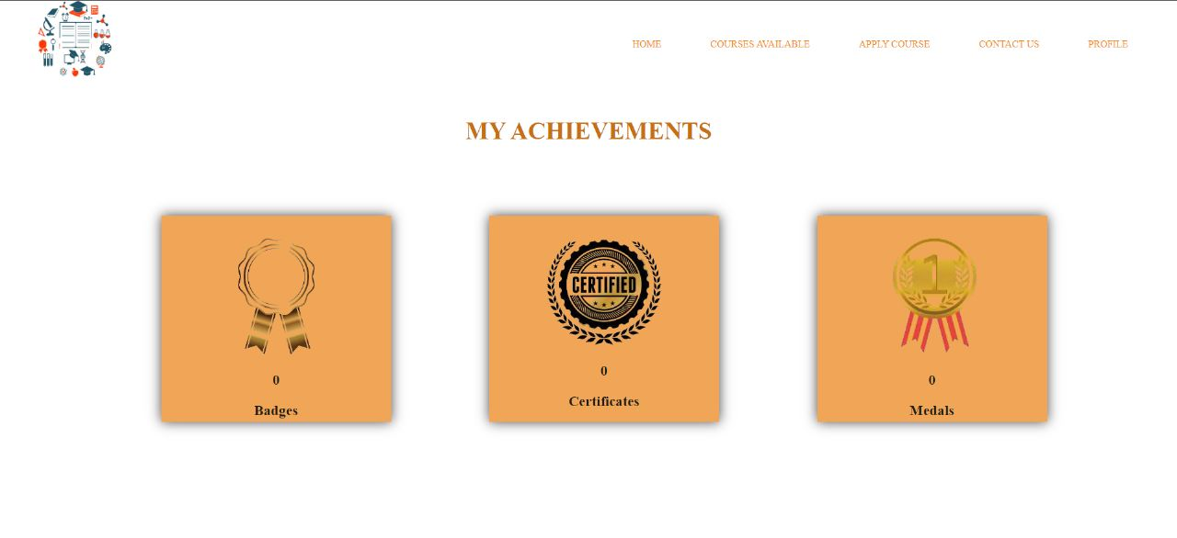

**CONTACT US PAGE:**

The contact us page should include a contact form where users can send inquiries, suggestions, and feedback about the website. They can also contact the admin for further details.

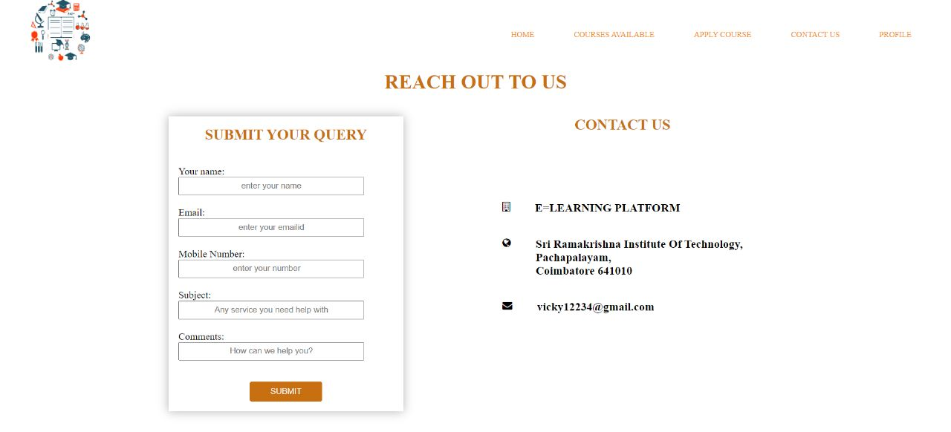

**ASSESSMENT:**

|  |  |  |  |
| --- | --- | --- | --- |
| **Sl.No.** | **DESCRIPTION** | **WEIGHTAGE** | **MARKS AWARDED** |
| 1 | Logic | 1 |  |
| 2 | Output | 1 |  |
| 3 | Viva | 1 |  |
| Total | | 3 |  |

**Signature of the Faculty**

E-learning is an education via the Internet, network, or standalone computer. E-learning is

basically the network-enabled convey of skills and knowledge. E-learning refers to using

electronic appli

PRODUCT SCOPE 4

PRODUCT DESCRIPTION 5

PRODUCT PERSPECTIVE 5

PRODUCT FUNCTIONALITY 5

USERS AND CHARACTERISTICS 5

OPERATING ENVIRONMENT 6

SPECIFIC REQUIREMENTS 7

FUNCTIONAL REQUIREMENTS 7

BEHAVIORAL REQUIREMENTS 7

Use case Diagram 7

EXTERNAL INTERFACE REQUIREMENTS 10

USER INTERFACE 10

Hardware Interfaces 10

NON-FUNCTIONAL REQUIREMENTS 10

PERFORMANCE REQUIREMENTS 10

SAFETY AND SECURITY REQUIREMENTS 10

SOFTWARE QUALITY ATTRIBUTES 11

CHAPTER 1: INTRODUCTION

E-learning is an education via the Internet, network, or standalone computer. E-learning is

basically the network-enabled convey of skills and knowledge. E-learning refers to using

electronic applications and processes to learn. E-learning includes all forms of electronically

supported learning and teaching. The

.1 System Introduction

This project focuses on developing an E-learning website which provides facility to institute

and students in a manner that the learning, evaluation; assessment does not remain limited to

the four wall of a classroom. Student and Instructor are the main parts of this system. By

building this system we will facilitate the student and the Instructor. Through this system the

Student can learn academic courses. Instructors can easily upload the video lectures. Student

can also enroll by paying the University fee.

.1 System Introduction

This project focuses on developing an E-learning website which provides facility to institute

and students in a manner that the learning, evaluation; assessment does not remain limited to

the four wall of a classroom. Student and Instructor are the main parts of this system. By

building this system we will facilitate the student and the Instructor. Through this system the

Student can learn academic courses. Instructors can easily upload the video lectures. Student

can also enroll by paying the University fee.

.1 System Introduction

This project focuses on developing an E-learning website which provides facility to institute

and students in a manner that the learning, evaluation; assessment does not remain limited to

the four wall of a classroom. Student and Instructor are the main parts of this system. By

building this system we will facilitate the student and the Instructor. Through this system the

Student can learn academic courses. Instructors can easily upload the video lectures. Student

can also enroll by paying the University fee.